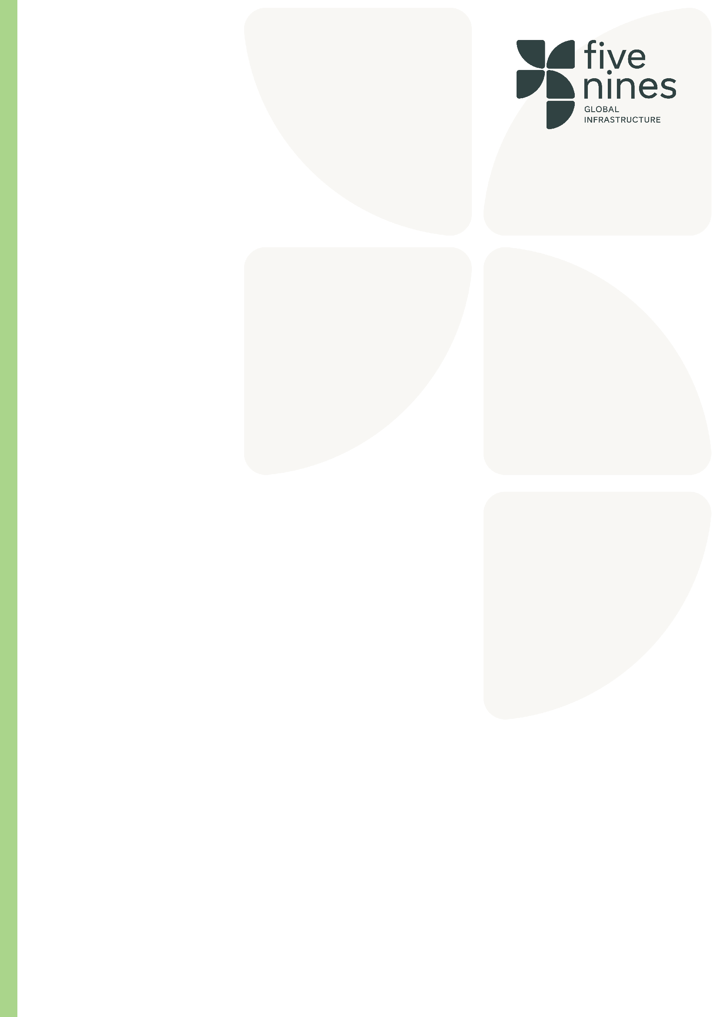

Role | Senior Engineer
Tier | Professional/Skilled Specialist
Job Family | International Operations
Reports to
Direct Report(s)
Location(s) | Finland

Role Purpose
The Senior Engineer is responsible for supporting the planning, coordination, design management and delivery of civil, structural, concrete and underground utility packages throughout the project. Act as technical link between the client, designers, subcontractors and project delivery team, ensuring that engineering solutions are practical, compliant, buildable and delivered safely in accordance with project requirements.
.
Key Responsibilities
- Support the planning, coordination, delivery and technical assurance of civil, structural, foundation, concrete and underground services packages.
- Review and coordinate engineering designs, drawings, calculations, specifications and technical submissions to ensure compliance with project requirements, client standards and applicable regulations.
- Manage technical interfaces between structures, foundations, underground services, temporary works, utilities, architectural and MEP disciplines.
- Support the development and coordination of Stage 3, Stage 4 and construction-stage design deliverables in collaboration with designers, subcontractors and client teams.
- Identify and manage design risks, technical queries, RFIs, constructability issues and engineering constraints.
- Coordinate underground utility installations including drainage, water, stormwater, telecoms, electrical ducting, earthing systems and other buried infrastructure.
- Monitor foundation, structural and utility works to ensure compliance with approved drawings, specifications, quality standards and project programme requirements.
- Participate in design reviews, technical workshops, value engineering exercises and coordination meetings.
- Liaise with clients, designers, subcontractors, utility providers and authorities to ensure efficient project delivery and resolution of technical issues.
- Assist with programme planning, sequencing of works and identification of opportunities to improve buildability, cost efficiency and project delivery.
- Ensure all engineering activities are carried out in accordance with FiveNines health, safety, environmental and quality management systems.
- Support inspections, testing, quality assurance activities, NCR management and handover documentation.
- Mentor and support junior engineers, site engineers and graduates where required.
- Provide regular progress updates, technical reports and engineering support to the delivery team.
- Carry out any other duties reasonably required to support the successful delivery of the project.

Qualifications
- Degree in Civil Engineering, Structural Engineering or related discipline.

Desirable experience
- Minimum 5-10 years relevant experience.
- Data Centre experience.
- Utility infrastructure experience.
- Concrete and foundation experience.
- BIM/Revit/Navisworks experience.
- Finnish construction industry experience.

Key Competencies

Competency | Description | Level
Regulatory and legal awareness | Understands relevant laws, regulations, and industry standards to ensure compliance and mitigate risk. | Advanced/Expert
 | Significant experience in the Civils Sector
Sector Knowledge | Detailed knowledge of Utility and construction sectors
Communications | Excellent written and verbal skills
Site Management | Excellent construction and site management skills with good attention
Compliance | Knowledge of construction procurement contract documents and practice

Our Values

Capability: Our people are our edge. We attract, retain, and develop the best people in the industry. We build high-performance teams that deliver, time and again.

Curiosity: We seek smarter ways to build. We embrace innovation and technology to overcome complexity and deliver better outcomes. We solve the impossible.

Community: Partnership is in our DNA. We work collaboratively across clients, colleagues, and supply chains, united by trust, transparency, and shared goals.

Compliance: Everyone has to do it; we do it better. We go beyond the basics, setting the standard in safety, sustainability, quality, and regulation. It’s not a tick-box; it’s a mindset.
Commitment: Mission-critical is our comfort zone. We thrive under pressure and take pride in delivering where others hesitate; reliably, safely, and exceptionally.

