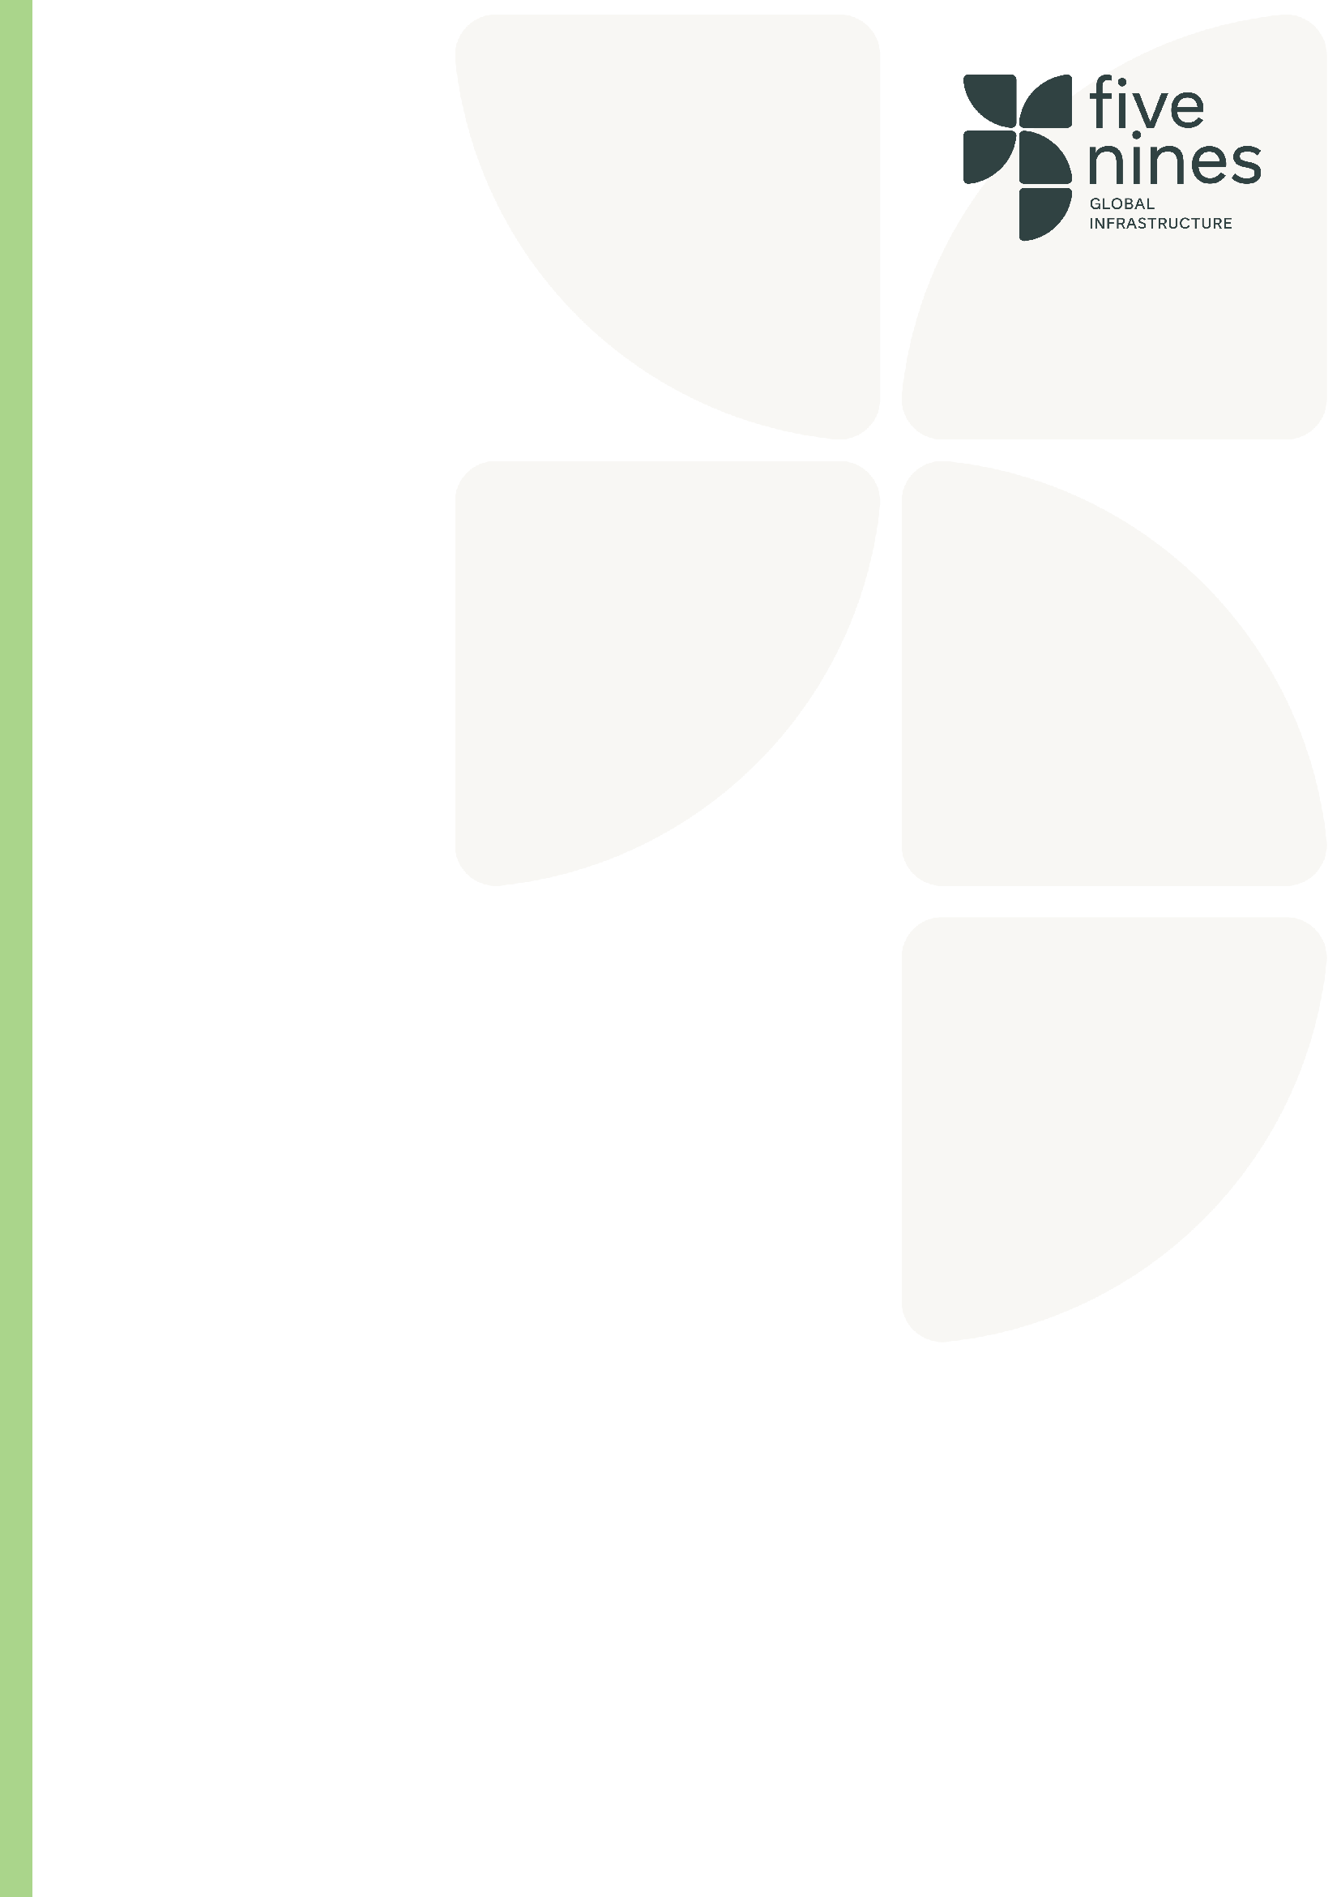

Role | Document Controller
Tier | Professional/Skilled Specialist
Job Family
Reports to
Location(s) | Finland

Role Purpose
As a Document controller/Site Administrator your role is critical in the support of technical teams, departments and projects in the filing and storing of project related documentation. Documentation may be of a confidential or sensitive nature and need to be stored in line with company and industry guidelines.
Key Responsibilities
- Controlling both company and project documentation
- Responsible for site inductions
- Responsible for ensuring all operatives training certificates are check and are uploaded to internal company portal
- Responsible for managing time sheets and inputting hours into internal database
- Preparing, operating and updating document control procedures
- Ensuring all documentation meets format requirements and client/company standards
- Producing document progress reports for Project Managers as required
- Conducting regular review audits
- Collecting and storing files from various company departments
- Using computer software to facilitate the organisation and distribution of documents within a company
- Helping to ensure documents are requested and delivered at the appropriate times to help contribute towards timely project completion
- Any other reasonable requests by management
- It is expected that all of your behaviours and day to day activities will be underpinned by the FiveNines company core values

Qualifications, Skills & Experience
- Minimum of 4 GCSEs or equivalent – Grading A*-C
- Experience in IT Administration
- Knowledge within the construction industry

Key Competencies

Competency | Description | Level
Regulatory and legal awareness | Understands relevant laws, regulations, and industry standards to ensure compliance and mitigate risk. | Advanced/Expert
IT Experience | thorough knowledge of IT administration | Expert
Industry Knowledge | A good understanding/knowledge within the construction industry

Our Values

Capability: Our people are our edge. We attract, retain, and develop the best people in the industry. We build high-performance teams that deliver, time and again.

Curiosity: We seek smarter ways to build. We embrace innovation and technology to overcome complexity and deliver better outcomes. We solve the impossible.

Community: Partnership is in our DNA. We work collaboratively across clients, colleagues, and supply chains, united by trust, transparency, and shared goals.

Compliance: Everyone has to do it; we do it better. We go beyond the basics, setting the standard in safety, sustainability, quality, and regulation. It’s not a tick-box; it’s a mindset.
Commitment: Mission-critical is our comfort zone. We thrive under pressure and take pride in delivering where others hesitate; reliably, safely, and exceptionally.

