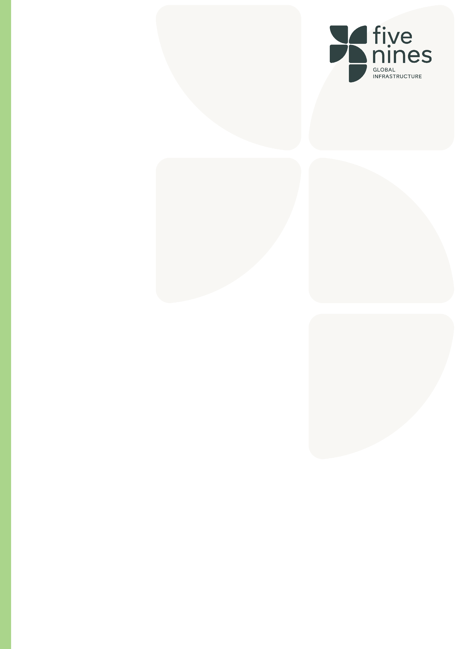
.

Role | Design Manager
Tier | Professional/Skilled Specialist
Job Family | Technical
Reports to
Direct Report(s)
Location(s) | Finland

Role Purpose
As a Design Manager you will be responsible for coordinating the design work involved across the entire construction process.

Key Responsibilities
- Leading design project meetings
- Overseeing external design teams
- Liaising with other teams and departments
- Working with clients to ensure that their requirements are fulfilled, and expectations met
- Making sure that design information is available to those who need it, when they need it
- Maintaining thorough documentation of all processes
- Keeping up to date with changing legislation and codes of practice to ensure compliance
- Requires a thorough understand of technical, regulatory and commercial issues as well as pure design
- considerations
- Input to design at tender through to project completion
- Maintaining design programmes
- Drive forward value engineering and innovation into the project designs
- Any other reasonable requests as required by Management
- It is expected that of your behaviours and day to day activities will be underpinned by the FiveNines company core values.

ESSENTIAL AND DESIRABLE SKILLS
• Ability to work well under pressure and manage a heavy workload
• Excellent written and verbal communication skills
• Good self-motivation and the ability to motivate others
• Excellent people skills
• The ability to present ideas effectively and evaluate the ideas of others whilst in meetings
• Experience in Temporary work designs
• Experience in external public realm design (Hard/Soft landscaping)
• Be honest and reliable

Qualifications, Skills & Experience

- Civil Engineering degree or equivalent
- HNC/HND/degree in Construction Management or Architecture
- BSc in Design and Construction Management

Key Competencies

Competency | Description | Level
Design process from tender to completion | Ability to provide technical and regulatory knowledge within the designs | Expert
Design Programmes | Advanced and expert knowledge in designing programmes with maintaining throughout projects. | Expert
Leadership | Strong ability to drive forward engineering and innovation within design projects and overseeing external design teams | Expert
Communication | Ensuring design information is provided to all that is required with strong presentation skills | Advanced

Our Values

Capability: Our people are our edge. We attract, retain, and develop the best people in the industry. We build high-performance teams that deliver, time and again.

Curiosity: We seek smarter ways to build. We embrace innovation and technology to overcome complexity and deliver better outcomes. We solve the impossible.

Community: Partnership is in our DNA. We work collaboratively across clients, colleagues, and supply chains, united by trust, transparency, and shared goals.

Compliance: Everyone has to do it; we do it better. We go beyond the basics, setting the standard in safety, sustainability, quality, and regulation. It’s not a tick-box; it’s a mindset.
Commitment: Mission-critical is our comfort zone. We thrive under pressure and take pride in delivering where others hesitate; reliably, safely, and exceptionally.

